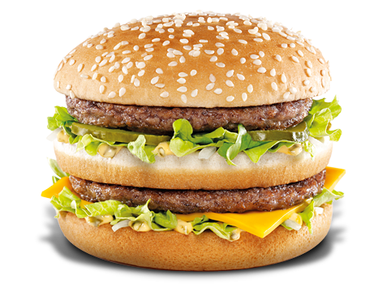
Which Burger is Better?

You will need to be able to access the website of McDonald’s and Hungry Jack’s to view their menu items and use the provided nutritional information to complete the tasks successfully.
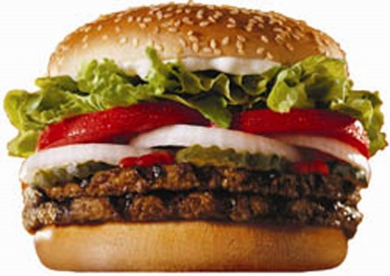
Task 1 – The Signature Burger
VS
How much does the Big Mac cost? __________________
How much energy in kJ does the Big Mac contain? ________________
How much does the Whopper cost?
How much energy in kJ does the Whopper have? _________________

Taking into account of the price and kilojoule content of the Big Mac and Whopper, which burger is the better burger? Explain how you made your decision.

Task 2
Toby is running late for work and decides to head to McDonald’s for a breakfast value meal. He orders a Bacon and Egg McMuffin Value Meal with a coffee. As Toby is finishing his breakfast at work, Marie tells him that the Bacon and Egg Wrap Value Meal would have been healthier.
Use the information provided by McDonald’s to determine whether Marie is correct.

Task 3
It is recommended that an active 16 year old needs 12 000 kJ per day. Is it possible to have three meals in a day from McDonalds and Hungry Jack’s that will meet this requirement?
List what you would recommend to order for breakfast, lunch, and dinner from both outlets.

Task 4
Health Freak Café also offers burgers. This is their menu selection:
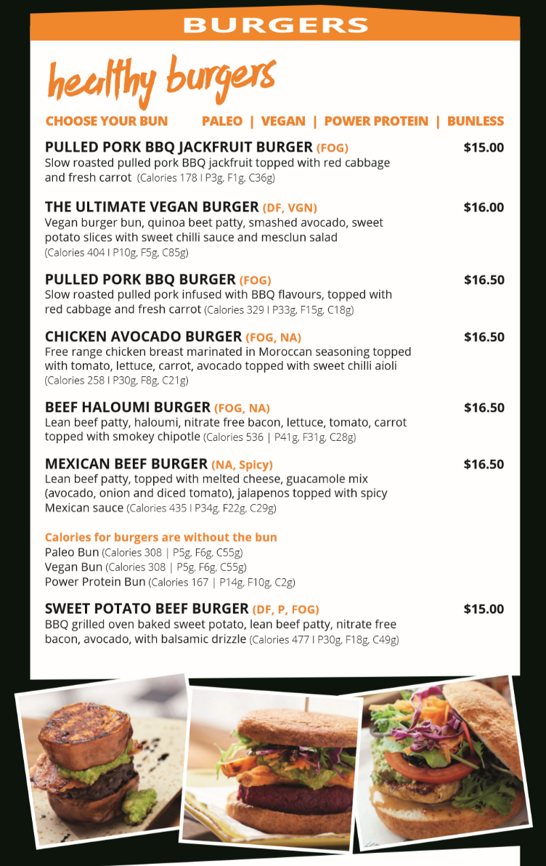
They say that their burgers are healthy. Choose a burger from Health Freak Café and compare the information with a similar burger from McDonald’s and Hungry Jack’s. Are Health Freak Café burgers healthier?

